**Right to Read Week**

**May 1st-5th, 2017**



**Dear Prospect Families,**

Right to Read Week is coming up. In celebration of this important week, we have a special theme: **Great Children’s Authors**

Each day of the week, we will learn about a different children’s book author. We will honor them by setting aside a time to read their books and do some fun activities each day!

**Monday: Patricia Polacco**

**“Dress Like Your Hero”**

In many of Patricia’s books she references the people she considered HEROES in her life. Dress like a hero in your life today!

**Tuesday: Dr. Seuss**

**“Favorite Character”**

Dr. Seuss wrote many books with wonderful main characters. Today, dress like your favorite Dr. Seuss book character!

**Wednesday: Eric Carle and Jane O’Connor**

**“Colorful and Fancy”**

All of Eric Carle books are bright, bold and colorful. Jane O’Connor wrote the great *Fancy Nancy* books. Dress in your most colorful or fancy clothes today!

**Thursday: Shel Silverstein**

**“Black and White”**

Shel Silverstein illustrated many of his children’s books with just drawings in black and white. Today, honor Shel by wearing only black and white clothing!

**Friday: Mo Willems**

**“Knuffle Bunny” (Stuffed Animal)**

Mo Willems is a wonderful children’s book author and illustrator. One of his most famous books is *Knuffle Bunny*, which is about a boy’s favorite stuffed animal. Bring your favorite stuffed animal to read with at school today!

Activities

Monday: Superhero Writing and Place Value

Tuesday: Write your own Imaginary Character and Dr. Seuss Word Problems

Wednesday: Story Elements, Fashion Boutique and Math Journal Entries

Thursday: Giving Tree Writing and Measuring in Inches

Friday: Speech Bubbles and Graphing

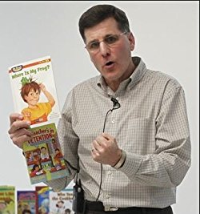

Paul Orshoski

Don’t forget to join us Monday, May 1st at 10:30 am to see a wonderful presentation by children’s author, Paul Orshoski!